Task 1

Instructions: Your first weekly project requires you to **submit** a review of 4-5 different data visualizations used to answer specific questions. Some fun websites are [pudding.cool](https://pudding.cool/), [fivethirtyeight](https://fivethirtyeight.com/), and [priceonomics](https://priceonomics.com/), but you can use any website, blog, or article with a good visualization.

The **submit** word above means you will post your reviews to teams.

Example 1.) Serena William Once and lifetime serve.

Url: <https://fivethirtyeight.com/features/serena-williams-us-open/>

Paragraph: This is a very interesting article about serena Williams. As we all know that Serena is a world class tennis player but what we didn’t know was how crazy good her serve was. This visualization shows how dominant her has been since 2008, she has more aces than anybody else, with over 300 more than her closest competitor. I like how she is highlighted in green so we can instantly compare. I think the visualization makes it very clear to see the difference between Serena and her competitors. I wish they would have given a little bit of a key explaining more about what the “share of service” is. Also could have made it a little more appealing than just green and grey.

Example 2: Does spending big prevent newly promoted premier teams from Relegation.

Url: <https://fivethirtyeight.com/features/does-spending-big-save-newly-promoted-premier-league-teams-from-relegation/>

Viz

Paragraph: being a big fan of soccer there has been lots of trends but most of the time you see this trends with big clubs. But with smaller clubs trying to move up and make a name for themselves how do they “Move up”. Well this means many things, but for most smaller clubs this means they have to spend more money just to try and keep up with the bigger clubs. This visualization shows not only are smaller clubs spending more money but bigger clubs are also spending more money, I like to see the spike drop right after covid due to clubs not having the income due to covid to buy more player but this year they seem to spending much more. I wish they would have averaged out the spending to a % then compared each club based on how much % more thay are spending then the previous year or over a 5 year time span.

Example 3.) Canceling school debt could help close the wealth gap between white and black americans.

Url: <https://fivethirtyeight.com/features/canceling-student-debt-could-help-close-the-wealth-gap-between-white-and-black-americans/>

Paragraph: with school debt being a big issue in America I found this visualization to be very interesting. When looking up there you can see that on average those who are of black ethnicity are a $10,000 more in debt than anybody else that being more Hispanic, white or Asian. I wish they could have blown this up, using a different visual so it could help show how dramatic that difference really is, feels just like a basic chart. Even though it is basic it is extremely informative and easy to understand.

Example 4: The NFL preseason is not predictive but it can often seem that way.

URL: <https://fivethirtyeight.com/features/the-nfl-preseason-is-not-predictive-but-it-can-often-seem-that-way/>

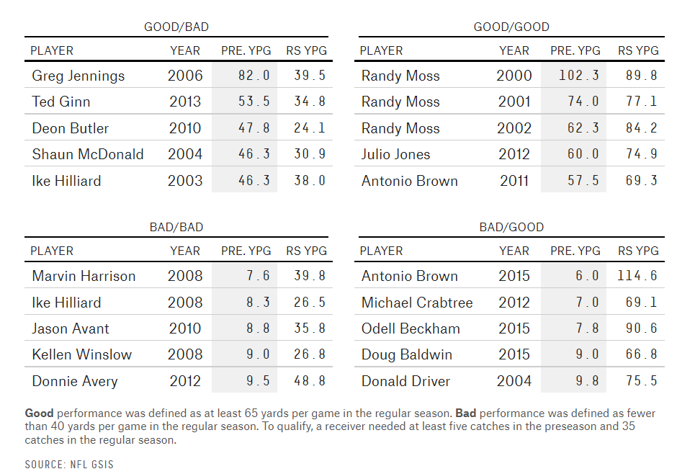

Paragraph: this article I found to interesting but it also seems to have some flaws. They compared how wide receivers did during there pre season and then how they did compared to the actual season. I found this to be kind of a no brainer, because during preseason a team is not usually playing the starting squad, this means they are putting out new players to see how they perform, so you are not actually the best vs the best, this means that those that had a good pre season could have been playing teams that were just trying new players to see if they could make it. I think they should have included more visualizations as well duck a little deeper and compared the beginning of a season and end of season to really break it up, but overall very good and easy to read and understand